PYSPARK RDD PROCESSING

SETUP:
- !apt-get -y install openjdk-11-jdk-headless > /dev/null
- !pip -q install pyspark==3.5.1
- import os
- os.environ["JAVA_HOME"] = "/usr/lib/jvm/java-11-openjdk-amd64"
- from pyspark import SparkConf, SparkContext
- from operator import add
- conf=SparkConf().setAppName("Healthcare_RDD_Separate").setMaster("local[*]")
- sc = SparkContext.getOrCreate(conf)
- sc.setLogLevel("ERROR")
- def load_csv_rdd(path, delimiter=","):
- rdd = sc.textFile(path)
- header = rdd.first()
- return rdd.filter(lambda line: line != header).map(lambda line: [x.strip() for x in line.split(delimiter)])
- paths = {
- "address": "/content/Address.csv",
- "claim": "/content/Claim.csv",
- "contain": "/content/Contain.csv",
- "disease": "/content/Disease.csv",
- "insurance_company": "/content/InsuranceCompany.csv",
- "insurance_plan": "/content/InsurancePlan.csv",
- "keep": "/content/Keep.csv",
- "medicine": "/content/Medicine.csv",
- "patient": "/content/Patient.csv",
- "person": "/content/Person.csv",
- "pharmacy": "/content/Pharmacy.csv",
- "prescription": "/content/Prescription.csv",
- "treatment": "/content/Treatment.csv",}
- address_rdd = load_csv_rdd(paths["address"])
- claim_rdd = load_csv_rdd(paths["claim"])
- contain_rdd = load_csv_rdd(paths["contain"])
- disease_rdd = load_csv_rdd(paths["disease"]) # not used in problems below, loaded for completeness
- ins_company_rdd = load_csv_rdd(paths["insurance_company"])
- ins_plan_rdd = load_csv_rdd(paths["insurance_plan"])
- keep_rdd = load_csv_rdd(paths["keep"]) # not used, loaded for completeness
- medicine_rdd = load_csv_rdd(paths["medicine"])
- patient_rdd = load_csv_rdd(paths["patient"])
- person_rdd = load_csv_rdd(paths["person"])
- pharmacy_rdd = load_csv_rdd(paths["pharmacy"])
- prescription_rdd = load_csv_rdd(paths["prescription"])
- treatment_rdd = load_csv_rdd(paths["treatment"])
- def year_of(date_str): # "YYYY-MM-DD" -> "YYYY"
- return date_str[:4]
- treat_to_year = treatment_rdd.map(lambda r: (r[0], year_of(r[1]))) # (treatmentID, year)
- t21 = set(treat_to_year.filter(lambda kv: kv[1] == "2021").map(lambda kv: kv[0]).collect())
- t22 = set(treat_to_year.filter(lambda kv: kv[1] == "2022").map(lambda kv: kv[0]).collect())
- t21_bc = sc.broadcast(t21)
- t22_bc = sc.broadcast(t22)
- t2122_bc = sc.broadcast(t21 | t22) print("Setup complete ✔")

- Listing each insurance plan, its issuing company, and the number of treatments claimed under it."
CODE:
- uin_to_plan = ins_plan_rdd.map(lambda r: (r[0], (r[1], r[2])))
- claims_by_uin = claim_rdd.map(lambda r: (r[2], 1))
- plan_claims = claims_by_uin.join(uin_to_plan) \ .map(lambda kv: (kv[1][1][0], 1)) \.reduceByKey(add)
- plan_to_company = uin_to_plan.map(lambda kv: (kv[1][0], kv[1][1]))
- company_id_name = ins_company_rdd.map(lambda r: (r[0], r[1]))
- problem2_output = plan_claims.join(plan_to_company) \
- .map(lambda kv: (kv[1][1], (kv[0], kv[1][0]))) \
- .join(company_id_name) \
- .map(lambda kv: (kv[1][1], kv[1][0][0], kv[1][0][1])) \
- .sortBy(lambda r: (r[0], -r[2]))
- print("Problem 2 (companyName, planName, claimCount):")
- for row in problem2_output.take(20):
- print(row)

OUTPUT:
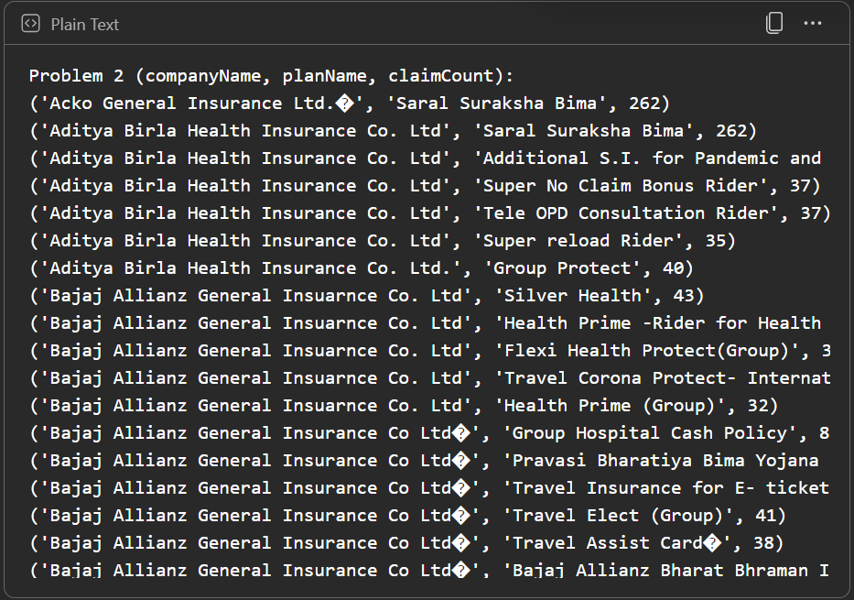

- Listing each insurance company with its most and least claimed insurance plans.
CODE:
- by_company = problem2_output.map(lambda r: (r[0], (r[1], r[2])))
- grouped = by_company.groupByKey()
- def max_min_plans(plans_iter):
- items = list(plans_iter)
- if not items:
- return (None, 0), (None, 0)
- return max(items, key=lambda x: x[1]), min(items, key=lambda x: x[1])
- problem3_output = grouped.mapValues(max_min_plans) \
- .map(lambda kv: (kv[0], kv[1][0][0], kv[1][0][1], kv[1][1][0],kv[1][1][1]))
- # Format: (companyName, mostPlan, mostCount, leastPlan, leastCount)
- print("Problem 3 (companyName, mostPlan, mostCount, leastPlan, leastCount):")
- for row in problem3_output.take(20):
- print(row)

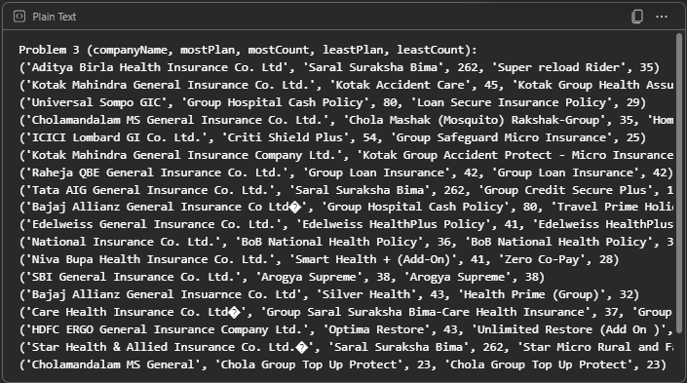
OUTPUT:

- Listing state-wise health report showing state name, registered people, registered patients, and people-to-patient ratio, sorted by ratio.
CODE:
- person_state = person_rdd.map(lambda r: (r[4], 1))
- addr_to_state = address_rdd.map(lambda r: (r[0], r[3]))
- people_by_state = person_state.join(addr_to_state) \
- .map(lambda kv: (kv[1][1], kv[1][0])) \
- .reduceByKey(add)
- # Patients per state: Patient IDs present in Person (assume equality)
- patient_ids = set(patient_rdd.map(lambda r: r[0]).collect())
- patient_bc = sc.broadcast(patient_ids)
- patients_person = person_rdd.filter(lambda r: r[0] in patient_bc.value) \
- .map(lambda r: (r[4], 1))
- patients_by_state = patients_person.join(addr_to_state) \
- .map(lambda kv: (kv[1][1], kv[1][0])) \
- .reduceByKey(add) # (state, patientsCount)
- # Join and compute ratio = people/patients (None if patients=0)
- problem4_output = people_by_state.fullOuterJoin(patients_by_state) \
- .map(lambda kv: (
- kv[0],
- kv[1][0] or 0,
- kv[1][1] or 0,
- (kv[1][0]/kv[1][1]) if (kv[1][0] and kv[1][1]) else None
- )) \
- .sortBy(lambda r: r[0])

- print("Problem 4 (state, peopleCount, patientsCount, people_to_patient_ratio):")
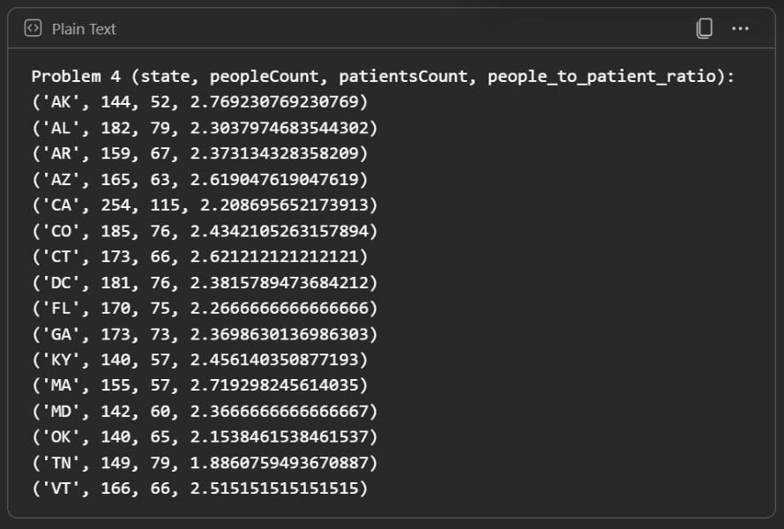
- for row in problem4_output.collect():

- print(row)

